Masonic Excellence Award
for Building Lodges
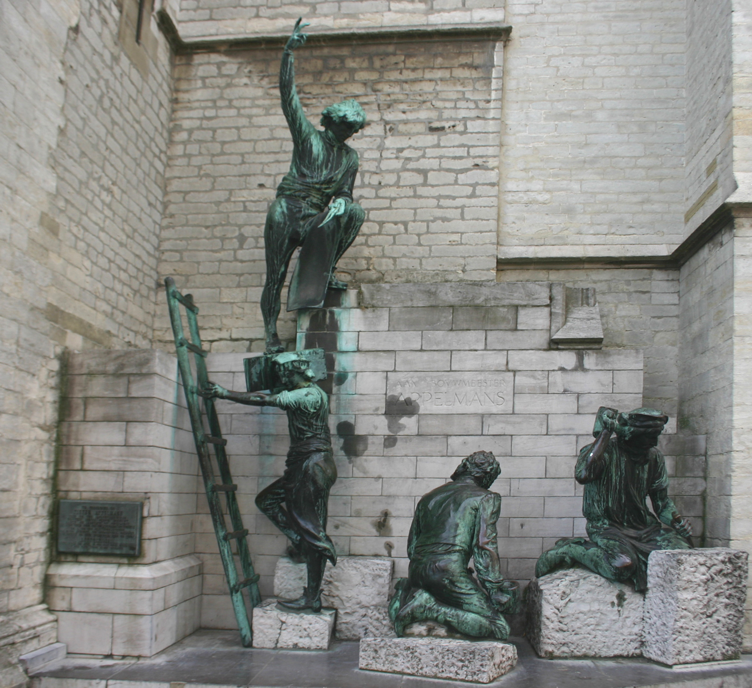
Monument to “Master Builders” Jans and Pieter Applemans
at the Cathedral of our Lady in Antwerp, Belgium. It honors the builders of the Temple, construction of which started in 1352.
Grand Lodge of Masons of Maine
2017
Masonic Excellence Award
“What came we here to do?” Individual Brethren and Lodges should periodically ask themselves this time old question and then pose the follow-up question, “Are we realizing our desires and expectations?”
Answering these questions in an honest and forthright manner allows us to consider what the expected and realized value of Lodge membership is to the individual Brother, his family, community and society in general.
Sometimes we get set in our ways, following the same old routine month after month. We meet monthly only to read the minutes and pay the bills, and never take a hard look at what we should be there to do. We overlook asking several big questions, including:
- What VALUE does the Lodge provide to Brethren, their families and the community?
- How does being a Lodge member afford opportunities for Brethren to improve themselves?
- Is the Lodge attractive, vibrant, warm, engaging … THE place where people WANT to be?
- What is the public awareness and perception of the Lodge, if they even know it exists?
- What will the Lodge look like and be doing just ten years from now?
Addressing these questions and many others is essential to gauging and enhancing the vitality of a Lodge and Maine Freemasonry overall. By Brethren taking the initiative to periodically address these questions, Lodges will become more vibrant and of greater value to their members and communities, and could earn them recognition within the Craft for pursing Masonic Excellence. And beginning this year, these questions will be central to the annual District Deputy Grand Master assessment of each Lodge.
The Masonic Excellence Award will be presented by the Grand Master of Maine beginning with the Grand Lodge Annual Communication in May 2017. Every Lodge is invited and urged to consider whether it wishes to pursue a course that will lead to enhancing the strength of the Lodge and the value of membership. The award is not a competition for a single plaque, but a challenge to us all to make Freemasonry all that it can be in our personal lives and communities. Hopefully, many Lodges will be recognized each year! The award is presented to recognize planning and achievements in the pursuit of excellence, not just those who have achieved that high level of performance!
The Award is designed to encourage and recognize Lodges, their officers and members for efforts to define and pursue their vision for their Lodge, a shared vision that leads to excellence in Masonry. The Award process will hopefully lead Masonic veterans and Rookies to define and work towards becoming the Lodge that members want it to be, and how they want their Lodge to be perceived ten years from now. It encourages Lodges to take stock of themselves – their traditions, member interests, strengths, opportunities, challenges; and then to develop strategies, goals and plans for becoming a more vibrant Masonic body – one that truly adds value to being a member of the Lodge and Maine Freemasonry, as well as one that adds value to the members’ families and their communities. Adding value should curb membership demits and suspensions.
Each Lodge has received a charter empowering the Brethren to work. The ultimate responsibility for defining and pursuing its vision – its destiny – falls to the members of that particular Lodge. Other Lodges in the District as well as the Grand Lodge and its District Officers and committees, the Maine Masonic Charitable Foundation and the Maine Masonic College are all available and willing to assist Lodges and Masons to prosper and grow.
What is the proper vision for your Lodge? Some Lodges emphasize fraternal relationships among members and their families; others stress and benefit from active community service and involvement; and some work hard on presenting quality ritual and insightful Masonic education. In reality, every Lodge should pursue a mix of those attributes, reflecting member interests, needs and opportunities.
Lodges interested in pursuing the award during 2017 will indicate their intentions to the Grand Secretary by December 31, 2016. Each participating Lodge will then submit its Masonic Excellence Award plan to by January 31, 2017, which will define its preliminary vision, identify its primary strengths and needs, and commit to pursue at least four new meaningful initiatives over the period ending January 31, 2018. The final report reflecting the Lodge’s 2017 accomplishments will be due at Grand Lodge by February 15, 2018.
The outline for the initial plan and the year-end report is laid out in the following pages, and is available in Word format on the Grand Lodge website, www.MaineMason.org. Please contact the Grand Secretary with any questions on the award process, and to request guidance and assistance in formulating a Lodge vision, undertaking a self-assessment, weighing priorities and identifying resources available from within the Fraternity.
Also attached is an optional tool called Lodge Strategic and Improvement Planning that may be used to undertake a self-assessment of your Lodge. Perhaps one or more Brethren could address a set of questions and bring their conclusions and recommendations back to a Lodge meeting for further discussion. This would help to identify Lodge needs and develop work plans. Attending the Dirigo Leadership Program entitled “Envisioning Your Future” would be beneficial to those who decide to undertake this Lodge improvement process.
In conclusion, pursuing of the Masonic Excellence Award is entirely optional for each Lodge, but undertaking the award planning process will materially benefit the health and vitality of the Lodge, and the value of being a Lodge member.
Masonic Excellence Award
Notice of Intention to Pursue the Award in 2017
Lodge: District:
Lodge Contact: Office:
Contact Email Address: Tel. #:

Our Lodge intends to pursue the Masonic Excellence Award in the upcoming year.
___ We would like more information on the award, assistance in undertaking a Lodge self-assessment, or a facilitator for discussions among members on the state of the Lodge and our vision and priorities for the future.

To assist our Lodge and others in the District in the pursuit of the Masonic Excellence Award, we might be willing to host (check any that may apply):
___ A complete Dirigo Leadership Seminar on a Saturday
___ The Dirigo “Envisioning Our Future” module on an evening
___ A Mentoring / Masonic Rookie seminar on an evening
___ A Lodge / District Masonic Fellowship (prospective candidate) event on an evening
___ A Maine Masonic College course on a Saturday or an evening

________________________________ ________________________________
Master Secretary

________________________________
Date Submitted

Due to the Grand Secretary by December 31, 2016
Masonic Excellence Award
Report on Initiatives Planned for /Undertaken in 2017
Lodge: District:
Lodge Contact: Office:
Contact Email Address: Tel. #:
This report is to be used to report preliminary lodge assessments and plans to the Grand Secretary by January 31, 2017, and then to report Lodge accomplishments for the year to the Grand Secretary by February 15, 2018. In addition to developing the Lodge vision and identifying its strengths etc., the Lodge needs to describe at least four new meaningful initiatives that it intends to pursue during 2017. Lodges may revise submitted plans during the year to update Lodge assessments and revise member priorities.
REQUIRED: Define Lodge Vision (what it wants to be viewed as or known for by Lodge members and the community in ten years; e.g. strong ritual and Masonic education; tight, welcoming fraternal bonds; community outreach; and charity).

REQUIRED: Define Lodge strengths, weaknesses (challenges), opportunities and threats – what you can build upon or need to address (e.g. membership development, engagement and retention; leadership team; finances; condition / cost of operating the building; ritual proficiency and Masonic education; community charity and recognition).

REQUIRED: Describe what is planned / has been accomplished to create the Lodge vision, define the Lodge focus and develop strategies and priorities for addressing Lodge challenges, opportunities and threats in the upcoming year and, in more general terms, over the upcoming five years (e.g. survey Lodge members, discuss in open Lodge, talk with former members and sons of members).
Long-range plan and increments to be undertaken in the upcoming year:

End of year review of accomplishments / progress:

Describe plans / accomplishments in at least four of the following areas

Describe what is planned / has been accomplished to identify and provide for member interests (e.g. conduct member survey and Lodge meeting discussions on: presentation of Masonic ritual and education, fraternal activities, community outreach, social events, etc.)
Long-range plan and increments to be undertaken in the upcoming year:

End of year review of accomplishments / progress:

Describe what is planned / has been accomplished to strengthen the Lodge leadership team and succession planning (e.g. identify and provide opportunities for personal growth; select and train officers; work on Lodge, District and Grand Lodge committees; host / attend Dirigo Leadership; involve new Brethren; attend Grand Lodge communications, District Meetings and District leadership meetings, role in District activities).
Long-range plan and increments to be undertaken in the upcoming year:

End of year review of accomplishments / progress:

Describe what is planned / has been accomplished to attract, engage and retain members – and especially to build member Value (e.g. hold fellowship night / open house / public-invited events; pursue presence in / contributions to the community; employ Mentoring, Rookie and Masonic education activities; participate in District activities; increase meeting attendance).
Long-range plan and increments to be undertaken in the upcoming year:

End of year review of accomplishments / progress:

Describe what is planned / has been accomplished to deliver strong ritual, as well as to offer ritual and symbolism related education programs and other education for the candidates and members (e.g. regular rehearsals; use of DER / DRI / Assistant Grand Lecturers; attendance at Schools of Instruction and Maine Masonic College; pursue ritual Lodge of the Year and the Raymond Rideout Awards; participate in District ritual competitions; member research and presentations on Masonry.)
Long-range plan and increments to be undertaken in the upcoming year:

End of year review of accomplishments / progress:

Describe what is planned / has been accomplished to strengthen the fraternal bonds among Lodge members, their families and with other Lodges (e.g. participate in district-wide events; sponsor / attend social activities for members, prospective members, family members and guests; hold widows and veteran activities; provide imaginative activities for younger members).
Long-range plan and increments to be undertaken in the upcoming year:

End of year review of accomplishments / progress:

Describe what is planned / has been accomplished to communicate regularly with Lodge members and the community (e.g. use Lodge / District trestle boards, newspapers, social media, Grand Lodge calendars and MORI email capabilities; establish calling tree; establish visitation program for senior, ailing and other shut-in Brethren and widows).
Long-range plan and increments to be undertaken in the upcoming year:

End of year review of accomplishments / progress:

Describe what is planned / has been accomplished to provide meeting facilities that are clean, safe, attractive and affordable (e.g. assess financial drain and building soundness; consider space sharing opportunities, use of alternate locations; develop multi-year plan to maintain, repair and update facilities; conduct insurance safety review; determine appropriateness of insurance coverage and compliance with the Grand Master’s 2016 insurance directive relative to Masonic buildings).
Long-range plan and increments to be undertaken in the upcoming year:

End of year review of accomplishments / progress:

Describe what is planned / has been accomplished to assure the financial strength and viability of the Lodge (e.g. employ budgeting process; identify potential significant future funding trends and outlays; assess dues & candidate fee structures; pursue fundraising approaches; utilize Maine Masonic Charitable Foundation grant programs).
Long-range plan and increments to be undertaken in the upcoming year:

End of year review of accomplishments / progress:

Describe what is planned / has been accomplished to assure that all Lodge and Building Association (if applicable) reports /payments to Grand Lodge, the State of Maine and IRS are made in a timely manner.
Long-range plan and increments to be undertaken in the upcoming year:

End of year review of accomplishments / progress:

Describe any other new initiatives to be pursued by the Lodge / Building Association in the upcoming year.

End of year review of accomplishments / progress:

